Q1.

**Entity Integrity(一致性) constraint：**

no primary key value can be NULL. This is because the primary key value is used to identify individual tuples in a relation. Having NULL values for the primary key implies that we cannot identify some tuples. For example, if two or more tuples had NULL for their primary keys, we may not be able to distinguish them if we try to reference them from other relations.

Primary key 代表entity，所以primary key不能為NULL

Primary key是代表資料庫每一筆tuple的idntity，所以primary key不能有NULL因為domain constraints，key是unique的

The primary key attributes PK of each relation schema R in S cannot have null values in any tuple of r(R).

This is because primary key values are used to identify the individual tuples.

t[PK] ≠ null for any tuple t in r(R)

If PK has several attributes, null is not allowed in any of these attributes

Note: Other attributes of R may be constrained to disallow null values, even though they are not members of the primary key.

**foreign key：**

reference the primary key attributes PK of the another referenced relation R2.

If a relation schema includes the primary key of another relation schema, that attribute is called the foreign key

Reference其他table的primary key的key

EX：

**EMPLOYEE**

|  |  |  |
| --- | --- | --- |
| SSN | SUPERSSN | DNO |
| e1 | e6 | 2 |
| e3 | e4 | 2 |
| e4 | e5 | 3 |

**WORK_ON**

|  |  |  |
| --- | --- | --- |
| ESSN | PNO | HOURS |
| e1 | p1 | 5 |
| e3 | p1 | 8 |
| e4 | p3 | 7 |
| e5 | p4 | 6 |

**DEPT**

|  |  |  |
| --- | --- | --- |
| DNumber | Dname | MGRSSN |
| 1 | Develop | e21 |
| 2 | Design | e21 |
| 3 | AI | e39 |

**WORK_ON**’s ESSN is a foreign key since it’s reference to **EMPLOYEE**‘s primary key (SSN)

**EMPLOYEE**’s DNO is a foreign key because it is reference to **DEPT**‘s primary key (Dnumber)

**DEPT**’s MGRSSN is a foreign key because it is reference to **EMPLOYEE**‘s primary key (SSN)

**referential integrity constraint：**

foreign key either reference存在的值or是NULL

specified between two relations and is used to maintain the consistency among tuples in the two relations. Informally, the referential integrity constraint states that a tuple in one relation that refers to another relation must refer to an existing tuple in that relation

A constraint involving two relations

The previous constraints involve a single relation.

Used to specify a relationship among tuples in two relations:

The referencing relation and the referenced relation.

Tuples in the referencing relation R1 have attributes FK (called foreign key attributes) that reference the primary key attributes PK of the referenced relation R2.

A tuple t1 in R1 is said to reference a tuple t2 in R2 if t1[FK] = t2[PK].

A referential integrity constraint can be displayed in a relational database schema as a directed arc from R1.FK to R2.

Statement of the constraint

The value in the foreign key column (or columns) FK of the the referencing relation R1 can be either:

(1) a value of an existing primary key value of a corresponding primary key PK in the referenced relation R2, or

(2) a null.

In case (2), the FK in R1 should not be a part of its own primary key

Q2

(a)

Common for Web applications

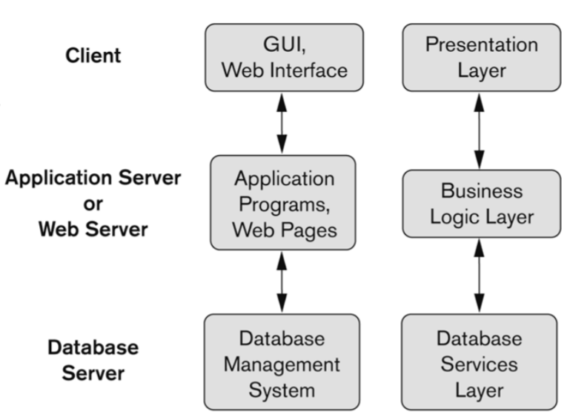

Clients

Provide user intervace. Let users can manupulate on it

Receiving user’s information and send to Intermediate Layer or presenting information from Intermediate Layer to users

Provide appropriate interfaces through a client software module to access and utilize the various server resources.

Clients may be diskless machines or PCs or Workstations with disks with only the client software installed.

Connected to the servers via some form of a network.

(LAN: local area network, wireless network, etc.)

Represents Web browser, a Java or other application, Applet, WAP phone etc. The client tier makes requests to the Web server who will be serving the request by either returning static content if it is present in the Web server or forwards the request to either Servlet or JSP in the application server for either static or dynamic content.

Intermediate Layer called Application Server or Web Server:

Provide appplication or logic operation

Stores the web connectivity software and the business logic part of the application used to access the corresponding data from the database server

Acts like a conduit for sending partially processed data between the database server and the client.

This layer provides the business services. This tier contains the business logic and the business data. All the business logic like validation of data, calculations, data insertion etc. Are centralized into this tier as opposed to 2-tier systems where the business logic is scattered between the front end and the backend. The benefit of having a centralized business tier is that same business logic can support different types of clients like browser, WAP (Wireless Application Protocol) client, other standalone applications written in Java, C++, C# etc. This acts as an interface between Client layer and Data Access Layer. This layer is also called the intermediary layer helps to make communication faster between client and data layer

Server

Provide access to database

Provides database query and transaction services to the clients

Relational DBMS servers are often called SQL servers, query servers, or transaction servers

Applications running on clients utilize an Application Program Interface (API) to access server databases via standard interface such as:

ODBC: Open Database Connectivity standard

JDBC: for Java programming access

This layer is the external resource such as a database, ERP system, Mainframe system etc. responsible for storing the data. This tier is also known as Data Tier. Data Access Layer contains methods to connect with database or other data source and to perform insert, update, delete, get data from data source based on our input data

Three-tier Architecture Can Enhance Security:

Database server only accessible via middle tier

Clients cannot directly access database server

Clients contain user interfaces and Web browsers

The client is typically a PC or a mobile device connected to the Web

High performance, lightweight persistent objects.

Scalability – Each tier can scale horizontally.

Performance – Because the Presentation tier can cache requests, network utilization is minimized, and the load is reduced on the Application and Data tiers.

Better Re-usability.

Improve Data Integrity.

Improved Security – Client is not direct access to database.

Forced separation of user interface logic and business logic.

Business logic sits on small number of centralized machines (may be just one).

Easy to maintain, to manage, to scale, loosely coupled etc.

(b)

(i) TRUE AND（FALSE OR UNKNOWN）🡢 TRUE AND UNKNOWN 🡢 UNKNOWN

(ii) (TRUE OR UNKNOWN) AND UNKNOWN 🡢 TRUE AND UNKNOWN 🡢 UNKNOWN

(iv) (TRUE AND UNKNOWN) OR (UNKNOWN OR UNKNOWN)

🡢 UNKNOWN OR UNKNOWN 🡢 UNKNOWN

Q3

Inherent (implicit) Constraints: These are based on the data model itself. Constraint which are inherent in the data model. (E.g., relational model does not allow a list as a value for any attribute)

Schema-based (explicit) Constraints: Constraint which can be expressed in the schema by using the facilities provided by the model, typically by specifying them in the DDL. (E.g., max. cardinality ratio constraint in the ER model)

Q4

(a)

通常不算NULL值

**WORKS_ON**

|  |
| --- |
| Hour |
| 8 |
| 10 |
| 8 |
| 12 |
| NULL |
| 10 |

Sum: 48

If the collection becomes empty because all values are NULL, SUM will return NULL

(b)

全部都是empty 🡺 Count return 0

如果是用Agggregate function且全部都是NULL 🡺 NULL

(c)

COUNT(*) ：

will return the total of all records returned in the result set regardless of NULL values.

counts the number of rows.

Count the number of tuple not of attribute 🡺 the tuple would be counted in

**WORKS_ON**

|  |
| --- |
| Hour |
| 8 |
| 10 |
| 8 |
| 12 |
| NULL |
| 10 |

COUNT (*)： 6

Q5

a

UPDATE COMPETITION

SET Score = ‘A’

WHERE Song_id IN (SELECT SG.Song_id

FROM SONG SG

WHERE SG.Language = ‘English’)

AND Student_number IN (SELECT ST.Student_number

FROM STUDENT ST

WHERE ST.Sex = ‘male’);

b

INSERT INTO SONG

VALUES (77,’English’,’Pop’,’BinMusic’);

c

DELETE FROM COMPETITION

WHERE Student_number IN (SELECT S.Student_number

FROM STUDENT S

WHERE S.Name = ‘Kelly’;

d

SELECT C1.Song_id

FROM COMPETITION C1

WHERE (SELECT COUNT (*)

FROM COMPETITION C2

WHERE Score = ‘B’ AND (SELECT (*)

FROM STUDENT

WHERE STUDENT.Student_number = C2.Student_number

AND STUDENT.Major = ‘MIS’) >= 2

AND C1.Song_id = C2.Song_id) >= 2;

Q6

(1)

SELECT FNAME, LNAME, COUNT (*)

FROM EMPLOYEE

GROUP BY SUPERSSN

HAVING COUNT (*) > 3;

(2)

SELECT E.FNAME, E.LNAME, S.FNAME, S.LNAME, COUNT (*)

FROM EMPLOYEE E, EMPLOYEE S, WORKS_ON

WHERE E.SSN = WORKS_ON.ESSN

AND E.SUPERSSN = S.SSN

AND NOT EXISTS (SELECT 1

FROM DEPARTMENT

WHERE DEPARTMENT.MGRSSN = E.SSN)

AND (SELECT COUNT (*)

FROM DEPENDENT

WHERE EMPLOYEE.SSN = DEPENDENT.ESSN) > 2;

GROUP BY WORKS_ON.ESSN;

(3)

SELECT DEPARTMENT.DNAME, M.SSN, COUNT (*)

FROM DEPARTMENT, EMPLOYEE.E, EMPLOYEE.M

WHERE E.DNO = DEPARTMENT.DNUMBER

AND E.SEX = ‘Male’

AND (SELECT COUNT (*)

FROM PROJECT

WHERE PROJECT.DNUM = DEPARTMENT.DNUMBER) > 5;

GROUP BY E.DNO;

(4)

SELECT M.FNAME, M.LNAME, DEPARTMENT.DNAME

FROM EMPLOYEE M, DEPARTMENT

WHERE M.DNO = DEPARTMENT.DNUMBER

AND M.SSN = DEPARTMENT.MGRSSN

AND NOT EXTSTS (SELECT *

FROM DEPEDENT

WHERE DEPEDENT.ESSN= M.SSN)

AND EXISTS (SELECT *

FROM EMPLOYMENT E

WHERE E.DNO = DEPARTMENT.DNUMBER

AND M.SALARY < E.SALARY)

(5)

WITH DNOtwoP (PNO, PCOUNT) AS

(SELECT WORKS_ON.PNO, COUNT (*)

FPOM EMPLOYEE , WORKS_ON

WHERE EMPLOYEE.DNO = 2 AND WORKS_ON.ESSN = EMPLOYEE.SSN

GROUP BY WORKS_ON.PNO)

SELELT PROJECT.PNAME, DEPARTMENT.DNAME

FROM DEPARTMENT, PROJECT

WHERE PROJECT.DNUM = DEPARTMENT.DNUMBER

AND (SELECT COUNT (*)

FROM WORKS_ON

WHERE PROJECT.PNUMBER = WORKS_ON.PNO)

> ALL (SELECT PCOUNT

FROM DNOtwoP);

(6)

SELECT PROJECT.PNAME, PROJECT.PLOCATION

FROM PROJECT, DEPARTMENT

WHERE PROJECT.DNUM = DEPARTMENT.DNUMBER

AND DEPARTMENT.DNAME = ‘R&D’

AND (SELECT COUNT (*)

FROM WORKS_ON

WHERE WORKS_ON.PNO = PROJECT.PNUMBER) >= 3;

(7)

SELECT EMPLOYEE.FNAME, EMPLOYEE.LNAME

FROM EMPLOYEE

WHERE NOT EXISTS ((SELECT W1.PNO

FROM PROJECT, DEPARTMENT, WORKS_ON W1

WHERE PROJECT.PLOCATION = ‘Hsinchu’

AND PROJECT.DNUM = DEPARTMENT.DNUMBER

AND DEPARTMENT.DNAME = ‘MIS’)

EXCEPT (SELECT W2.PNO

FROM WORKS_ON W2

WHERE W2.PNO = PROJECT.PNUMBER));

(8)

WITH RECURSIVE SUP_EMP (SupSSN, EmpSSN) AS

(SELECT SUPERSSN, SSN

FROM EMPLOYEE

UNION

SELECT S.SupSSN, E.SSN

FROM EMPLOYEE AS E, SUP_EMP AS S

WHERE E.SUPERSSN = S.EmpSSN)

SELECT E.FNAME, E.LNAME, S.FNAME, S.LNAME

FROM EMPLOYEE E, SUP_EMP SE, EMPLOYEE S, DEPARTMENT D1

WHERE E.SSN = SE.SupSSN

AND SE.EmpSSN = S.SSN

AND E.DNO = D1.DNUMBER

AND D1.DNAME = ‘Research’

AND NOT EXISTS (SELECT *

FROM DEPARTMENT D2

WHERE S.SSN = D2.MGRSSN)

AND (SELECT (*)

FROM SUP_EMP

WHERE E.SSN = EmpSSN) > 2;

Q7

(a)

(1) $_POST[ 'dept_name']

(2) $_POST[ 'emp_sal']

(3) DNUMBER = DNO

(b)

(4) $_POST[ 'dept_name']

(5) $_POST[ 'emp_sal']

(c)

(6) $q->fetchRow())

(7) $r[0]

(8) $r[1]

(9) $r[2]

Q8

(a)

$supervising = ['John' => 'Kevin', 'Darrel' => 'Tim', 'Mary' => 'Jack'];

(b)

foreach ($supervising as $emp_name => $sup_name)

{

echo "Employee $emp_name and his/her supervisor $sup_name.\n";

}